YFS flatfish mcmc

SSMA Authors

10/9/2018

## Marginals from MCMC runs

Model 2 (called Model 18_1 in SAFE) and Model 4 (called Model 14_2 in SAFE) need posterior of Fmsy, maybe on one figure?. For Model 18.1 (new base) need posteriors of Fmsy Bmsy, ABC biomass 2018, ABC biomass 2019, FSB and mean log recruitment.

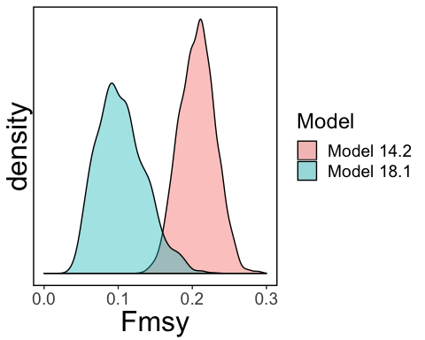

## Other plots

You can also embed plots, for example:

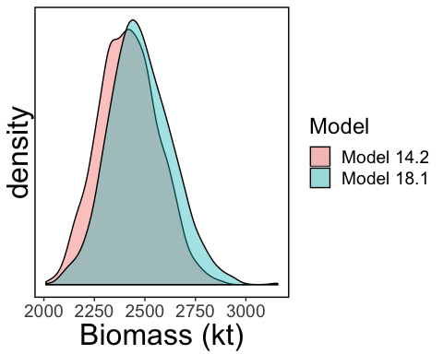

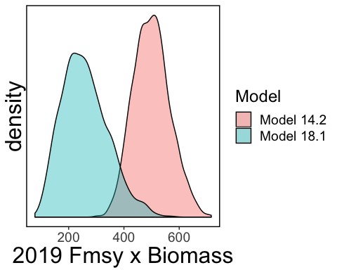

FABC

Biomass

ABC

0.1291972

2444.559

315.8302